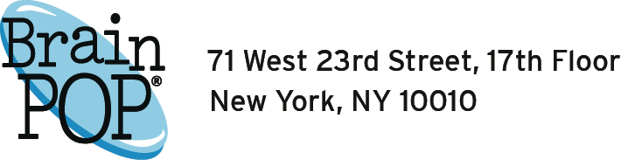

NHSTE Discounted Pricing Valid Until December 31, 2017
Schools-Per Site (ALL 24/7)
BrainPOP Jr. | $1235.00
BrainPOP | $1525.00
BrainPOP ESL | $590.00
Combo | $2035.00
Small School (Less than 250 enrolled)
BrainPOP Jr. | $975.00
BrainPOP | $1225.00
Combo | $1675.00
BrainPOP ESL | $375.00
Discounts  Multi-School | Multi-Year
5-9 schools- 10% | 2 year-10%
11-20 schools- 15% | 3 year-15%
21-30 schools- 20%
31-40 schools-25%
41+ schools-30%

To order and receive the NHSTE discount, make your PO out to: NHSTE, PO Box 358, Georges Mills, NH 03751. Fax: 603-763-3473
Contact Cyndy Currier at ccurrier@mac.com or 603-801-0444 for a quote or with questions.

- When switching a District subscription from per-student to the new per-building module, the multi-school discounts above take affect. If the difference in price is signifcant from previous district purchases then contact Cyndy to discuss further options.
- If all K-5/K-8/K-12 schools purchase together and have fewer than 5 schools in total, a 10% discount will be applied.
- Classroom accounts should be purchased thru BrainPOP directly and do not receive a discount. They can contact Subscriber Relations at info@brainpop.com or via phone at 866.542.7246

